Contact Manager
Ideation Phase
Brainstorm & Idea Prioritization

Date | 17/02/2026
Team ID | 69a7d7903987a2df4043eaef
Project Name | Contact Manager
Maximum Marks | 4 Marks

Brainstorm & Idea Prioritization
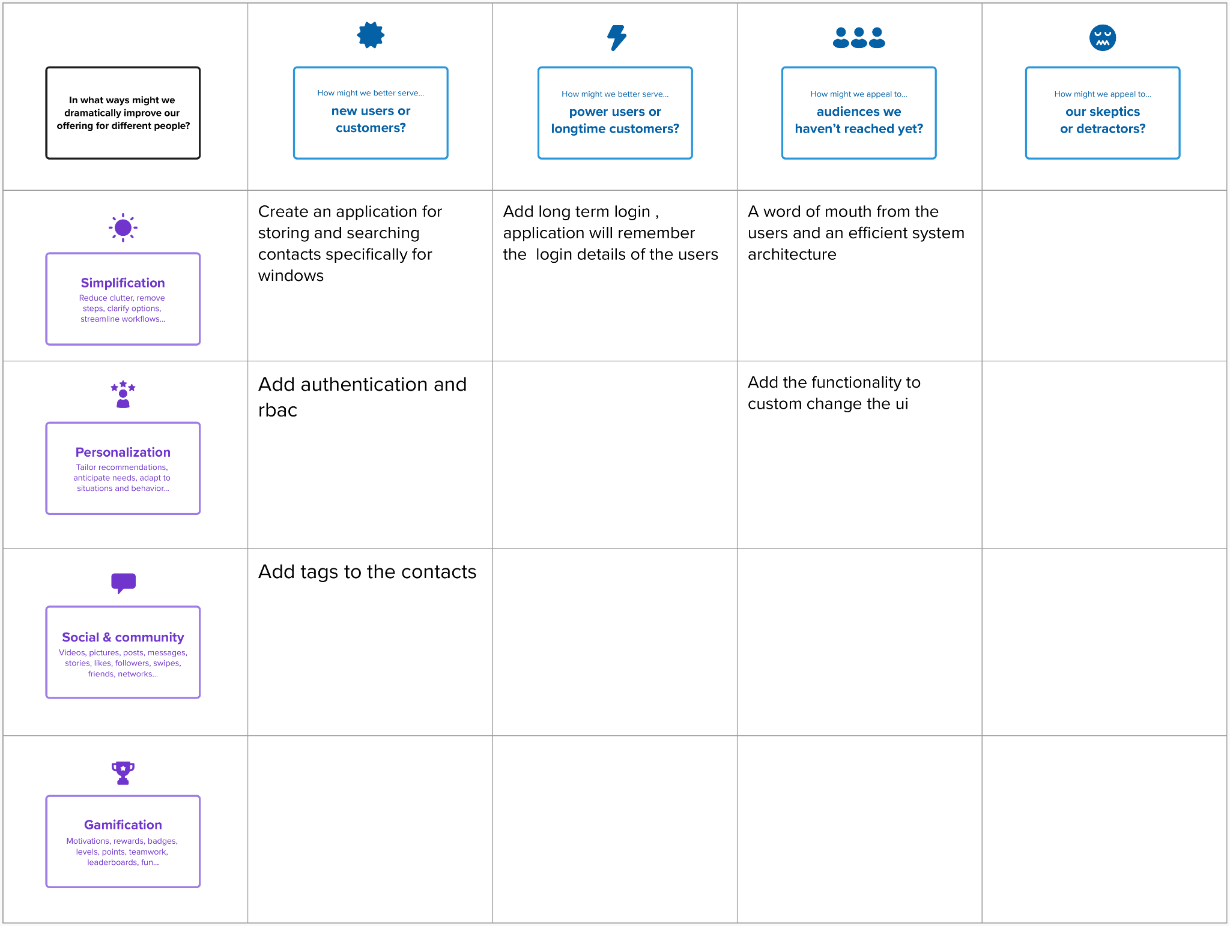
Show that the system improves productivity by making contact management simple and efficient.

Explain that Connect Hub helps users maintain strong connections by organizing and retrieving contact information quickly.
Encourage adoption among event organizers and professionals who manage large numbers of contacts.

Provide efficient tools for managing multiple client or business contacts in one place.

Enable users to categorize contacts using tags such as Work, Friends, Family, or Clients for better organization.
Assure users that their personal data is private and protected using authentication and secure access control.
Promote the system as a smart tool for building professional networks.

Provide quick insights such as the total number of contacts stored in the system.

Encourage users to build and maintain their contact network by regularly adding and updating contacts.

Demonstrate that the system is easy to use and reduces the difficulty of managing contacts scattered across multiple platforms.

Ste 2 : Idea Prioritization

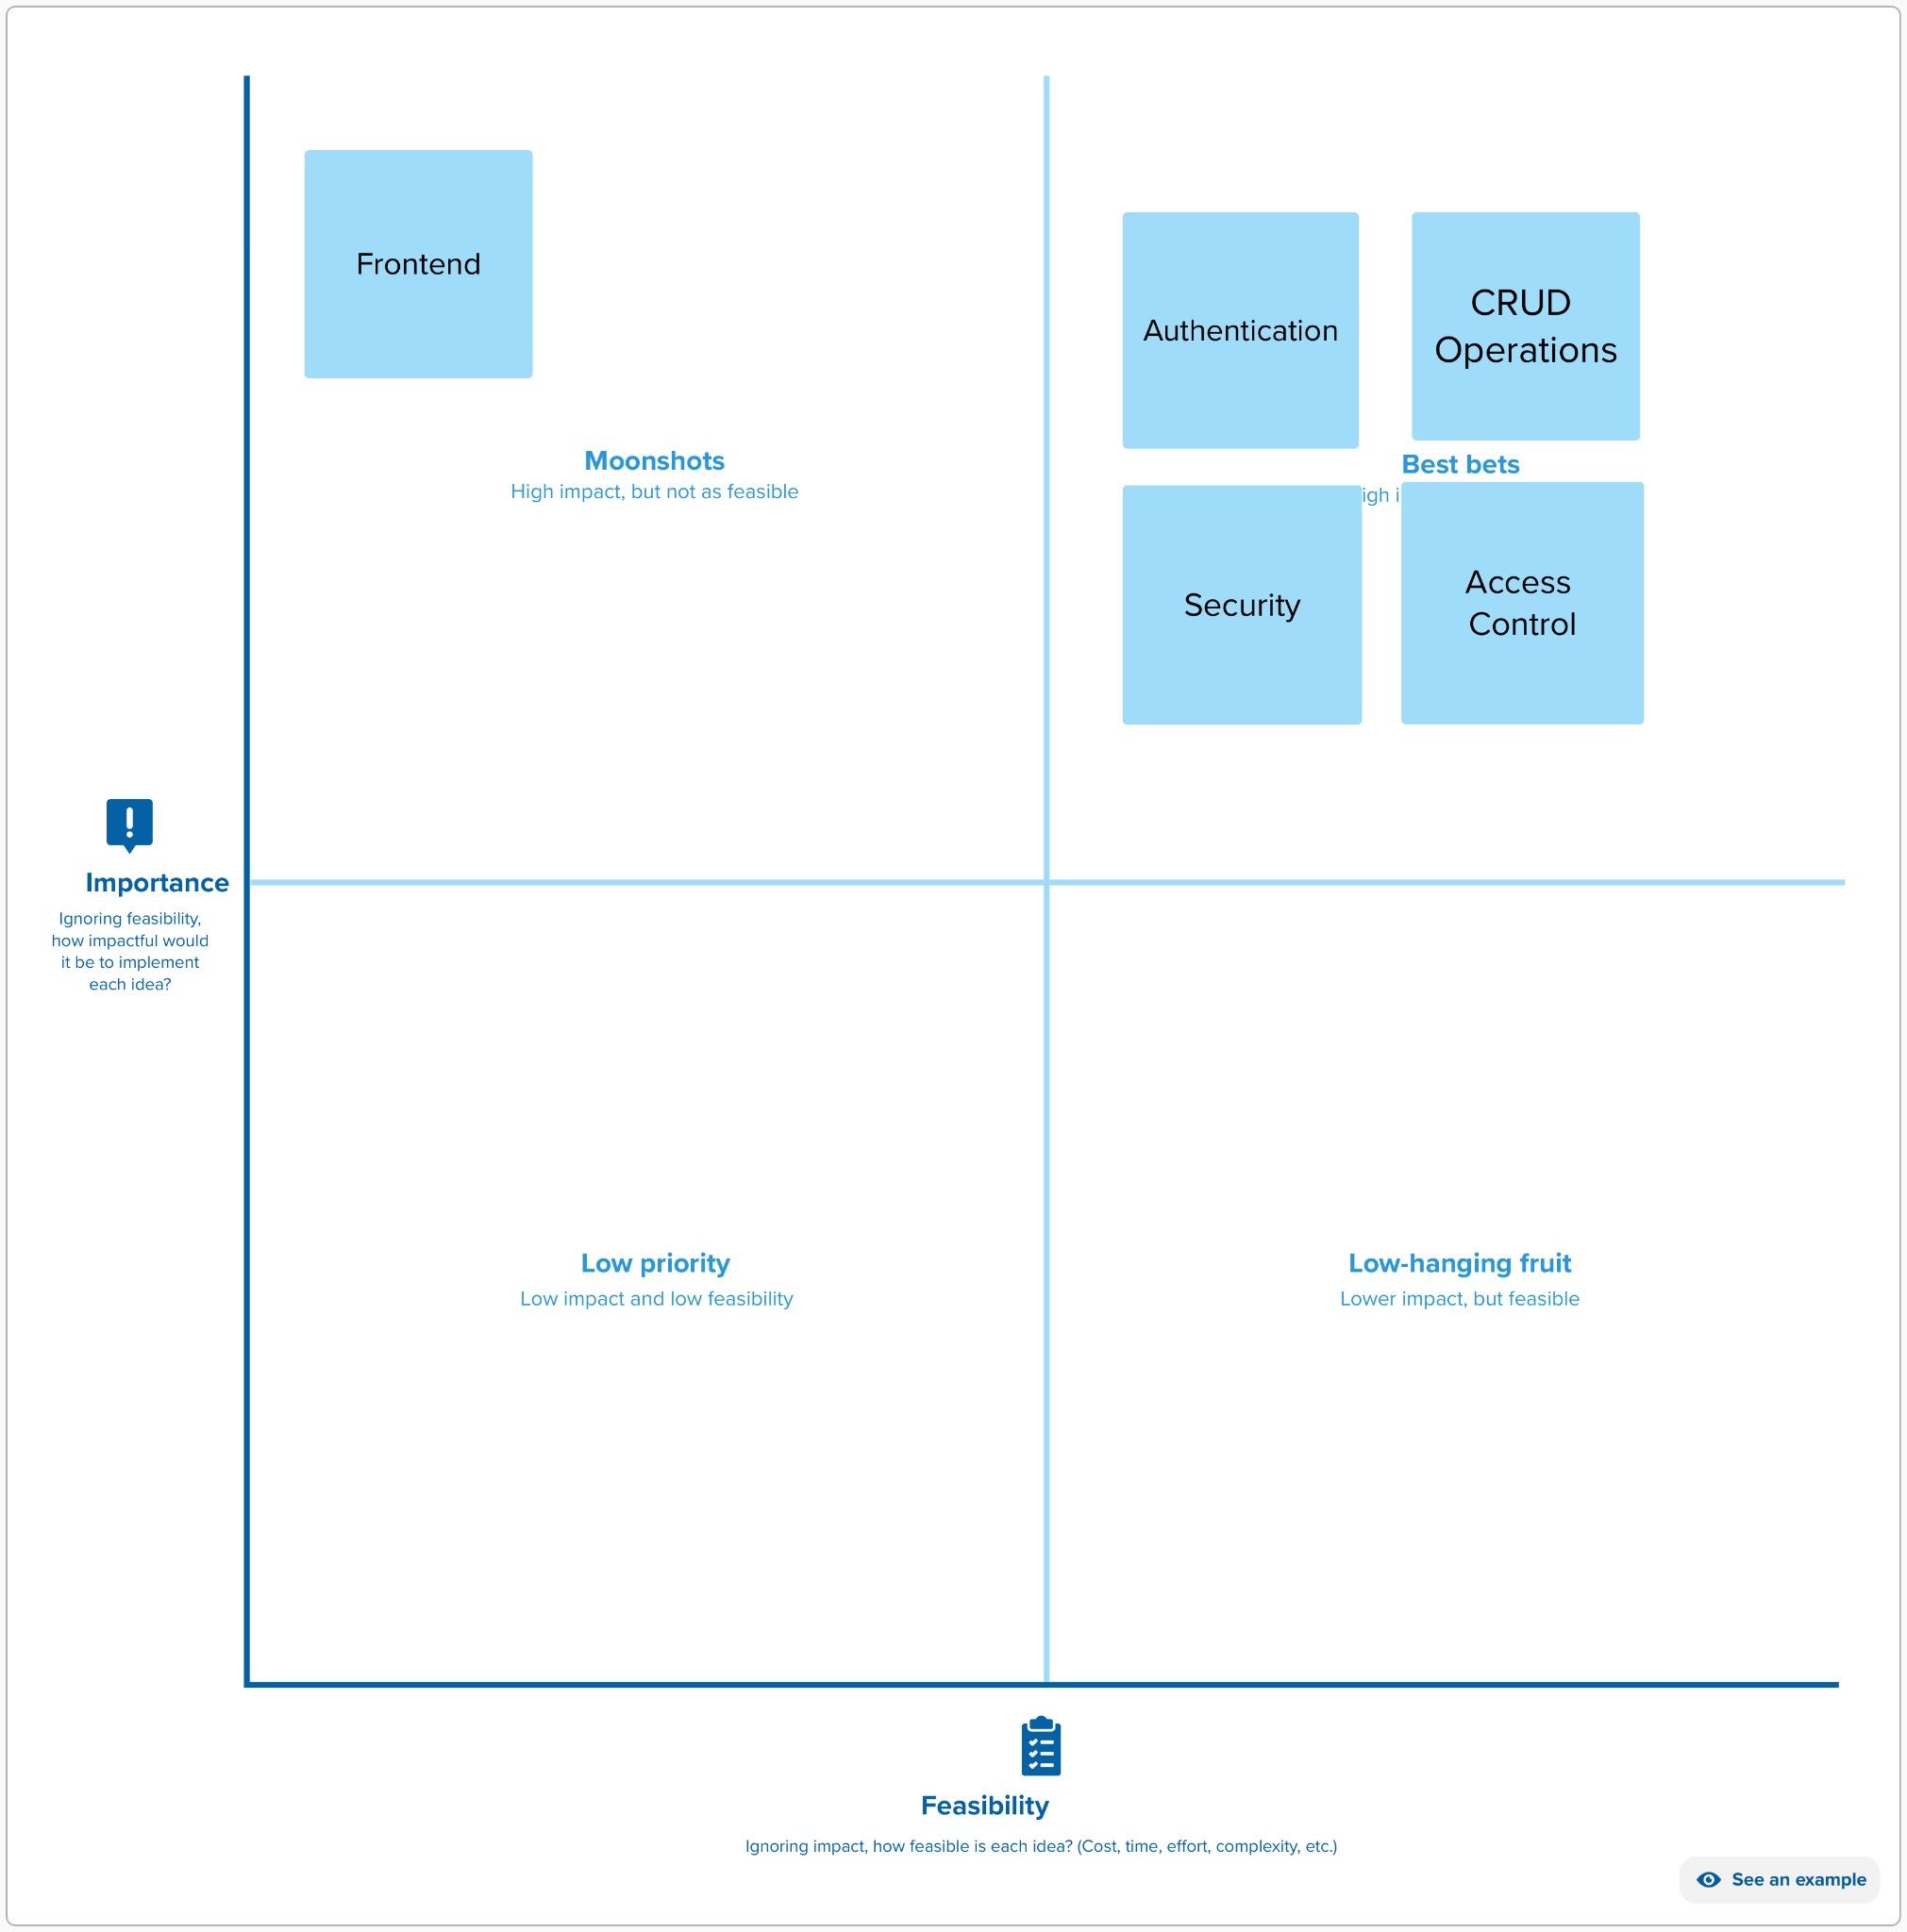
Contact count display

Contact sorting by name
Simple UI theme changes
Dark mode UI customization

Dark mode UI customization
Contact profile pictures

